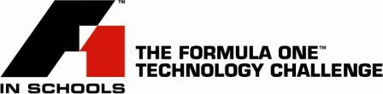

LYTHAM ST. ANNES PRIMARY SCHOOL STUDENTS RACE TO VICTORY IN FORMULA ONE CHALLENGE

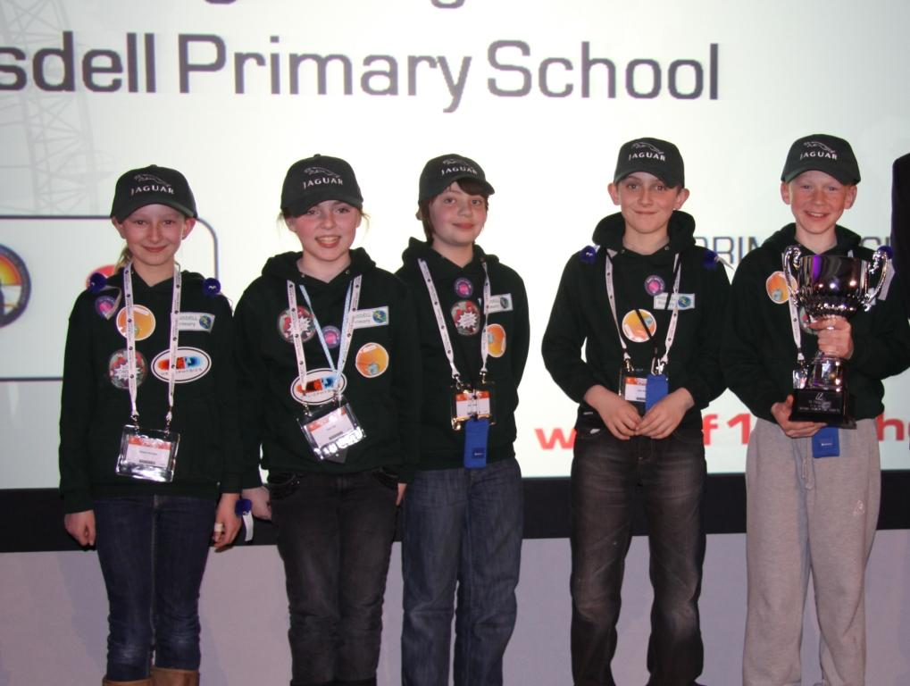
16 March 2010.../A team of Primary School students from Ansdell Primary School raced to a championship title in Manchester at the weekend, taking the Primary F1 in Schools crown after a closely fought race between teams and cars. The third Primary Formula One in Schools Technology Challenge National Finals held at the Big Bang Science Fair in Manchester proved highly competitive with ‘Green Lightning’, from the Ansdell, Lytham St Annes school, taking the Best Engineered Car Award on route to claiming overall victory.

The Team Manager of Green Lightning was Kate Hall, with her team mates including Kelsey Horridge, Graphic Designer, Lawrence Joyner and Alex Iredale, Design Engineers and Jack Adams, Manufacturing Engineer.

Runners Up to Green Lightning were a team of six students, ‘Flying Foxes’, from Norman Street Primary School, Carlisle, who also claimed the award for the Fastest Car. In third place and winner of the Best Sponsorship and Marketing award was Phoenix F1 from Cae Top School, Upper Bangor. Northern Ireland took home two awards with Best Team Identity being won by Groggan Zoom from Groggan Primary School, Antrim and the Innovative Thinking award won by Team Brent, West Winds Primary School, Newtownards.

Primary F1 in Schools is an expansion of the core F1 in Schools programme for students aged 11 – 19 years, which was launched ten years ago and now operates in over 30 countries worldwide. After a two year pilot programme, the Primary F1 in Schools initiatives was taken to a national level and after a series of regional events the top 12 teams competed at these National Finals. The competition challenges students to design, manufacture and race a miniature compressed air-powered racing car, introducing them to engineering and the key STEM subjects in a very compelling and fun educational programme.

Andrew Denford, Founder and Chairman, Primary F1 in Schools said of the National Finals, “To hold the first stand alone Primary National Final and to crown our third Primary F1 in Schools champions is a milestone event in the history of F1 in Schools. We’ve had tremendous support for taking the F1 in Schools programme into the Primary sector and both the students and the schools have embraced it, produced some excellent cars with plenty of innovative thinking and creativity. The standard is now at a level in Primary schools where we were with Secondary schools when we started 10 years ago! I’m sure our Primary programme will go from strength to strength over the coming years. “

Full results of Primary F1 in Schools 2010 National Finals

UK Champions and Best Engineered Car Green Lightning, Ansdell Primary School, Lytham St Annes
Runners Up and Fastest Car Award Flying Foxes, Norman Street Primary School, Carlisle
3rd place and Best Sponsorship and Marketing Award
Phoenix F1, Ysgol Cae Top, Upper Bangor
Best Team Identity Groggan Zoom, Groggan Primary School, Antrim, N. Ireland
Innovative Thinking Award Team Brent, West Winds Primary School, Newtownards, N Ireland

Ends.

Picture shows: Primary F1 in Schools champions, Green Lightning from Ansdell Primary School, Lytham St. Annes. From left to right: Kelsey Horridge, Kate Hall, Alex Iredale, Jack Adams and Lawrence Joyner.

For further information contact:
Alison Hill
F1 in Schools Press Office
Tel: 01327 856060/07710 306588
Alison@id-pr.co.uk

